Distribution System Analysis Subcommittee

IEEE 34 Node Test Feeder
IEEE 34 Node Test Feeder

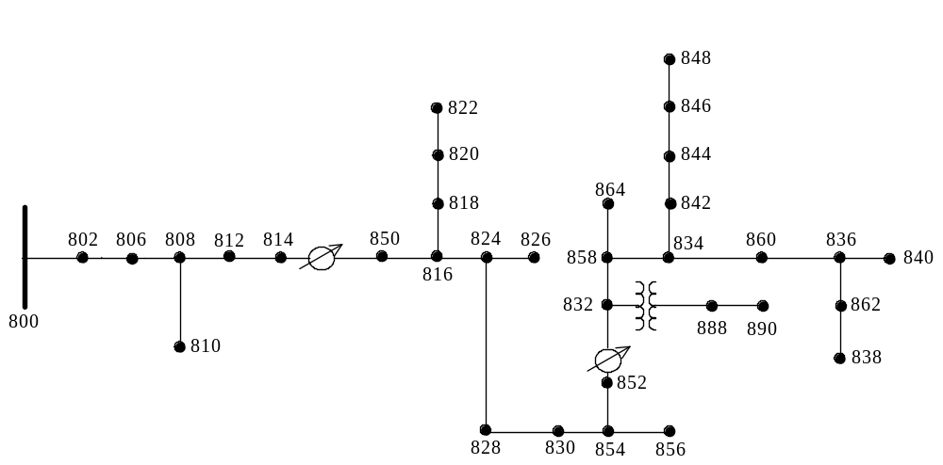

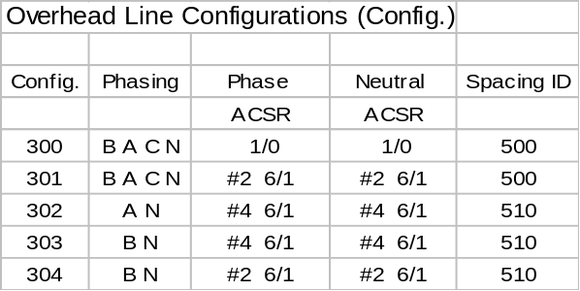
Line Segment Data
Node A
Node B
Length(ft.)
Config.
800
802
2580
300
802
806
1730
300
806
808
32230
300
808
810
5804
303
808
812
37500
300
812
814
29730
300
814
850
10
301
816
818
1710
302
816
824
10210
301
818
820
48150
302
820
822
13740
302
824
826
3030
303
824
828
840
301
828
830
20440
301
830
854
520
301
832
858
4900
301
832
888
0
XFM-1
834
860
2020
301
834
842
280
301
836
840
860
301
836
862
280
301
842
844
1350
301
844
846
3640
301
846
848
530
301
850
816
310
301
852
832
10
301
854
856
23330
303
854
852
36830
301
858
864
1620
302
858
834
5830
301
860
836
2680
301
862
838
4860
304
888
890
10560
300
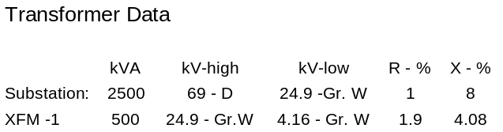
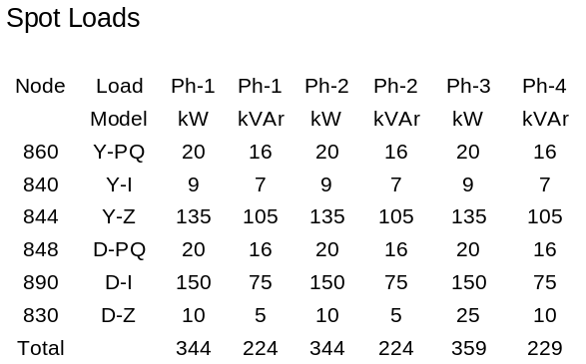
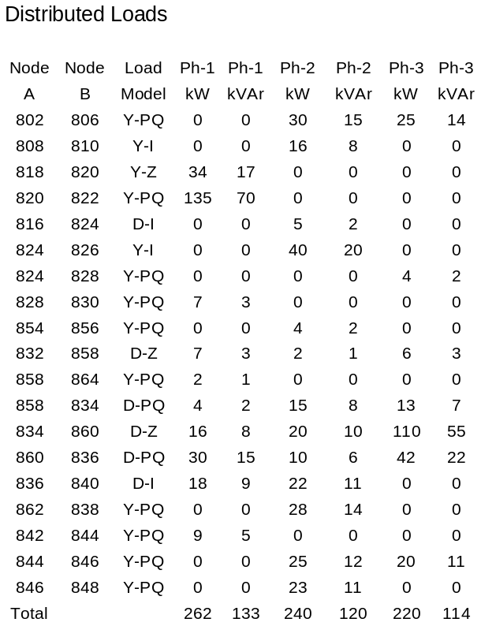
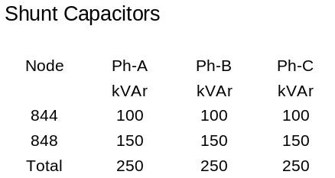

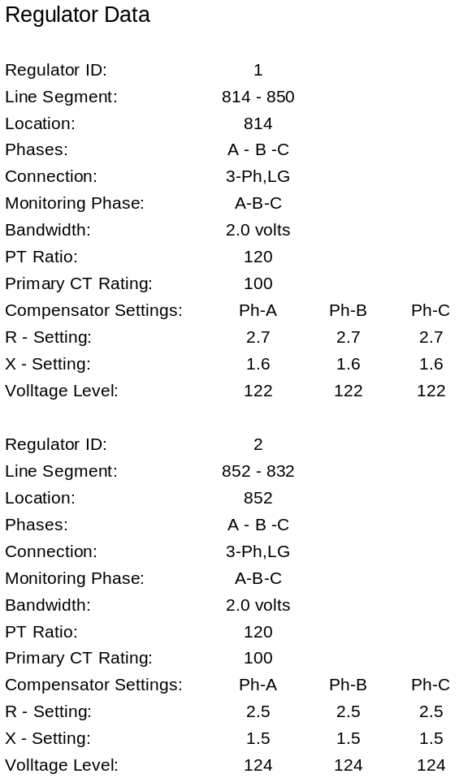

IEEE 34 Node Test Feeder
Impedances

Configuration 300:

--------- Z & B Matrices Before Changes ---------

Z (R +jX) in ohms per mile
1.3368 1.3343 0.2101 0.5779 0.2130 0.5015
1.3238 1.3569 0.2066 0.4591
1.3294 1.3471
B in micro Siemens per mile
5.3350 -1.5313 -0.9943
5.0979 -0.6212
4.8880
Configuration 301:

Z (R +jX) in ohms per mile
1.9300 1.4115 0.2327 0.6442 0.2359 0.5691
1.9157 1.4281 0.2288 0.5238
1.9219 1.4209
B in micro Siemens per mile
5.1207 -1.4364 -0.9402
4.9055 -0.5951
4.7154

Configuration 302:

Z (R +jX) in ohms per mile
2.7995 1.4855 0.0000 0.0000 0.0000 0.0000
0.0000 0.0000 0.0000 0.0000
0.0000 0.0000
B in micro Siemens per mile
4.2251 0.0000 0.0000
0.0000 0.0000
0.0000

Configuration 303:

Z (R +jX) in ohms per mile
0.0000 0.0000 0.0000 0.0000 0.0000 0.0000
2.7995 1.4855 0.0000 0.0000
0.0000 0.0000
B in micro Siemens per mile
0.0000 0.0000 0.0000
4.2251 0.0000
0.0000

Configuration 304:

Z (R +jX) in ohms per mile
0.0000 0.0000 0.0000 0.0000 0.0000 0.0000
1.9217 1.4212 0.0000 0.0000
0.0000 0.0000
B in micro Siemens per mile
0.0000 0.0000 0.0000
4.3637 0.0000
0.0000

Power Flow Results

- R A D I A L F L O W S U M M A R Y - DATE: 6-24-2004 AT 16:34:11 HOURS ---
SUBSTATION: IEEE 34; FEEDER: IEEE 34
-------------------------------------------------------------------------------
SYSTEM PHASE PHASE PHASE TOTAL
INPUT -------(A)-------|-------(B)-------|-------(C)-------|------------------
kW : 759.136 | 666.663 | 617.072 | 2042.872
kVAr : 171.727 | 90.137 | 28.394 | 290.258
kVA : 778.318 | 672.729 | 617.725 | 2063.389
PF : .9754 | .9910 | .9989 | .9901

LOAD --(A-N)----(A-B)-|--(B-N)----(B-C)-|--(C-N)----(C-A)-|---WYE-----DELTA--
kW : 359.9 246.4| 339.3 243.3| 221.8 359.0| 921.0 848.8
TOT : 606.322 | 582.662 | 580.840 | 1769.824
| | |
kVAr : 230.9 128.7| 216.9 128.7| 161.8 184.6| 609.6 441.9
TOT : 359.531 | 345.609 | 346.407 | 1051.547
| | |
kVA : 427.6 278.0| 402.7 275.3| 274.6 403.7| 1104.5 957.0
TOT : 704.903 | 677.452 | 676.293 | 2058.647
| | |
PF : .8417 .8864| .8425 .8840| .8078 .8894| .8339 .8870
TOT : .8601 | .8601 | .8589 | .8597

LOSSES ------(A)-------|-------(B)-------|-------(C)-------|------------------
kW : 114.836 | 80.389 | 77.824 | 273.049
kVAr : 14.200 | 10.989 | 9.810 | 34.999
kVA : 115.711 | 81.137 | 78.440 | 275.283

CAPAC --(A-N)----(A-B)-|--(B-N)----(B-C)-|--(C-N)----(C-A)-|---WYE-----DELTA--
R-kVA: 250.0 .0| 250.0 .0| 250.0 .0| 750.0 .0
TOT : 250.000 | 250.000 | 250.000 | 750.000
| | |
A-kVA: 265.7 .0| 264.8 .0| 265.9 .0| 796.3 .0
TOT : 265.658 | 264.760 | 265.869 | 796.287
--- V O L T A G E P R O F I L E ---- DATE: 6-24-2004 AT 16:34:18 HOURS ----
SUBSTATION: IEEE 34; FEEDER: IEEE 34
-------------------------------------------------------------------------------
NODE | MAG ANGLE | MAG ANGLE | MAG ANGLE |mi.to SR
-------------------------------------------------------------------------------
______|_______ A-N ______ |_______ B-N _______ |_______ C-N _______ |
800 | 1.0500 at .00 | 1.0500 at -120.00 | 1.0500 at 120.00 | .000
802 | 1.0475 at -.05 | 1.0484 at -120.07 | 1.0484 at 119.95 | .489
806 | 1.0457 at -.08 | 1.0474 at -120.11 | 1.0474 at 119.92 | .816
808 | 1.0136 at -.75 | 1.0296 at -120.95 | 1.0289 at 119.30 | 6.920
810 | | 1.0294 at -120.95 | | 8.020
812 | .9763 at -1.57 | 1.0100 at -121.92 | 1.0069 at 118.59 | 14.023
814 | .9467 at -2.26 | .9945 at -122.70 | .9893 at 118.01 | 19.653
RG10 | 1.0177 at -2.26 | 1.0255 at -122.70 | 1.0203 at 118.01 | 19.654
850 | 1.0176 at -2.26 | 1.0255 at -122.70 | 1.0203 at 118.01 | 19.655
816 | 1.0172 at -2.26 | 1.0253 at -122.71 | 1.0200 at 118.01 | 19.714
818 | 1.0163 at -2.27 | | | 20.038
820 | .9926 at -2.32 | | | 29.157
822 | .9895 at -2.33 | | | 31.760
824 | 1.0082 at -2.37 | 1.0158 at -122.94 | 1.0116 at 117.76 | 21.648
826 | | 1.0156 at -122.94 | | 22.222
828 | 1.0074 at -2.38 | 1.0151 at -122.95 | 1.0109 at 117.75 | 21.807
830 | .9894 at -2.63 | .9982 at -123.39 | .9938 at 117.25 | 25.678
854 | .9890 at -2.64 | .9978 at -123.40 | .9934 at 117.24 | 25.777
852 | .9581 at -3.11 | .9680 at -124.18 | .9637 at 116.33 | 32.752
RG11 | 1.0359 at -3.11 | 1.0345 at -124.18 | 1.0360 at 116.33 | 32.752
832 | 1.0359 at -3.11 | 1.0345 at -124.18 | 1.0360 at 116.33 | 32.754
858 | 1.0336 at -3.17 | 1.0322 at -124.28 | 1.0338 at 116.22 | 33.682
834 | 1.0309 at -3.24 | 1.0295 at -124.39 | 1.0313 at 116.09 | 34.786
842 | 1.0309 at -3.25 | 1.0294 at -124.39 | 1.0313 at 116.09 | 34.839
844 | 1.0307 at -3.27 | 1.0291 at -124.42 | 1.0311 at 116.06 | 35.095
846 | 1.0309 at -3.32 | 1.0291 at -124.46 | 1.0313 at 116.01 | 35.784
848 | 1.0310 at -3.32 | 1.0291 at -124.47 | 1.0314 at 116.00 | 35.885
860 | 1.0305 at -3.24 | 1.0291 at -124.39 | 1.0310 at 116.09 | 35.169
836 | 1.0303 at -3.23 | 1.0287 at -124.39 | 1.0308 at 116.09 | 35.677
840 | 1.0303 at -3.23 | 1.0287 at -124.39 | 1.0308 at 116.09 | 35.839
862 | 1.0303 at -3.23 | 1.0287 at -124.39 | 1.0308 at 116.09 | 35.730
838 | | 1.0285 at -124.39 | | 36.650
864 | 1.0336 at -3.17 | | | 33.989
XF10 | .9997 at -4.63 | .9983 at -125.73 | 1.0000 at 114.82 | 32.754
888 | .9996 at -4.64 | .9983 at -125.73 | 1.0000 at 114.82 | 32.754
890 | .9167 at -5.19 | .9235 at -126.78 | .9177 at 113.98 | 34.754
856 | | .9977 at -123.41 | | 30.195

----------- VOLTAGE REGULATOR DATA ---- DATE: 6-24-2004 AT 16:34:22 HOURS --
SUBSTATION: IEEE 34; FEEDER: IEEE 34
_______________________________________________________________________________
[NODE]--[VREG]-----[SEG]------[NODE] MODEL OPT BNDW
814 RG10 850 850 Phase A & B & C, Wye RX 2.00
........................................................................
PHASE LDCTR VOLT HOLD R-VOLT X-VOLT PT RATIO CT RATE TAP
1 122.000 2.700 1.600 120.00 100.00 12
2 122.000 2.700 1.600 120.00 100.00 5
3 122.000 2.700 1.600 120.00 100.00 5
_______________________________________________________________________________
[NODE]--[VREG]-----[SEG]------[NODE] MODEL OPT BNDW
852 RG11 832 832 Phase A & B & C, Wye RX 2.00
........................................................................
PHASE LDCTR VOLT HOLD R-VOLT X-VOLT PT RATIO CT RATE TAP
1 124.000 2.500 1.500 120.00 100.00 13
2 124.000 2.500 1.500 120.00 100.00 11
3 124.000 2.500 1.500 120.00 100.00 12
- R A D I A L P O W E R F L O W --- DATE: 6-24-2004 AT 16:34:32 HOURS ---
SUBSTATION: IEEE 34; FEEDER: IEEE 34
-------------------------------------------------------------------------------
NODE VALUE PHASE A PHASE B PHASE C UNT O/L<
(LINE A) (LINE B) (LINE C) 60.%
---------------------*--------A-------*-------B-------*-------C-------*--------
NODE: 800 VOLTS: 1.050 .00 1.050 -120.00 1.050 120.00 MAG/ANG
kVll 24.900 NO LOAD OR CAPACITOR REPRESENTED AT SOURCE NODE

TO NODE 802 .......: 51.56 -12.74 44.57 -127.70 40.92 117.37 AMP/DG
<802 > LOSS= 3.472: ( 1.637) ( .978) ( .858) kW
---------------------*--------A-------*-------B-------*-------C-------*--------
NODE: 802 VOLTS: 1.047 -.05 1.048 -120.07 1.048 119.95 MAG/ANG
-LD: .00 .00 .00 .00 .00 .00 kW/kVR
kVll 24.900 CAP: .00 .00 .00 kVR

FROM NODE 800 .....: 51.58 -12.80 44.57 -127.76 40.93 117.31 AMP/DG
<802 > LOSS= 3.472: ( 1.637) ( .978) ( .858) kW
TO NODE 806 .......: 51.58 -12.80 44.57 -127.76 40.93 117.31 AMP/DG
<806 > LOSS= 2.272: ( 1.102) ( .618) ( .552) kW
---------------------*--------A-------*-------B-------*-------C-------*--------
NODE: 806 VOLTS: 1.046 -.08 1.047 -120.11 1.047 119.92 MAG/ANG
-LD: .00 .00 .00 .00 .00 .00 kW/kVR
kVll 24.900 CAP: .00 .00 .00 kVR

FROM NODE 802 .....: 51.59 -12.83 42.47 -126.83 39.24 118.52 AMP/DG
<806 > LOSS= 2.272: ( 1.102) ( .618) ( .552) kW
TO NODE 808 .......: 51.59 -12.83 42.47 -126.83 39.24 118.52 AMP/DG
<808 > LOSS= 41.339: ( 20.677) ( 10.780) ( 9.882) kW
---------------------*--------A-------*-------B-------*-------C-------*--------
NODE: 808 VOLTS: 1.014 -.75 1.030 -120.95 1.029 119.30 MAG/ANG
-LD: .00 .00 .00 .00 .00 .00 kW/kVR
kVll 24.900 CAP: .00 .00 .00 kVR

FROM NODE 806 .....: 51.76 -13.47 42.46 -127.59 39.28 117.76 AMP/DG
<808 > LOSS= 41.339: ( 20.677) ( 10.780) ( 9.882) kW
TO NODE 810 .......: 1.22 -144.62 AMP/DG
<810 > LOSS= .002: ( .002) kW
TO NODE 812 .......: 51.76 -13.47 41.30 -127.10 39.28 117.76 AMP/DG
<812 > LOSS= 47.531: ( 24.126) ( 11.644) ( 11.761) kW
---------------------*--------A-------*-------B-------*-------C-------*--------
NODE: 810 VOLTS: 1.029 -120.95 MAG/ANG
-LD: .00 .00 kW/kVR
kVll 24.900 CAP: .00 kVR

FROM NODE 808 .....: .00 .00 AMP/DG
<810 > LOSS= .002: ( .002) kW

- R A D I A L P O W E R F L O W --- DATE: 6-24-2004 AT 16:34:32 HOURS ---
SUBSTATION: IEEE 34; FEEDER: IEEE 34
-------------------------------------------------------------------------------
NODE VALUE PHASE A PHASE B PHASE C UNT O/L<
(LINE A) (LINE B) (LINE C) 60.%
---------------------*--------A-------*-------B-------*-------C-------*--------
NODE: 812 VOLTS: .976 -1.57 1.010 -121.92 1.007 118.59 MAG/ANG
-LD: .00 .00 .00 .00 .00 .00 kW/kVR
kVll 24.900 CAP: .00 .00 .00 kVR

FROM NODE 808 .....: 51.95 -14.18 41.29 -127.99 39.33 116.90 AMP/DG
<812 > LOSS= 47.531: ( 24.126) ( 11.644) ( 11.761) kW
TO NODE 814 .......: 51.95 -14.18 41.29 -127.99 39.33 116.90 AMP/DG
<814 > LOSS= 37.790: ( 19.245) ( 9.140) ( 9.404) kW
---------------------*--------A-------*-------B-------*-------C-------*--------
NODE: 814 VOLTS: .947 -2.26 .994 -122.70 .989 118.01 MAG/ANG
-LD: .00 .00 .00 .00 .00 .00 kW/kVR
kVll 24.900 CAP: .00 .00 .00 kVR

FROM NODE 812 .....: 52.10 -14.73 41.29 -128.69 39.37 116.23 AMP/DG
<814 > LOSS= 37.790: ( 19.245) ( 9.140) ( 9.404) kW
TO NODE RG10 .<VRG>.: 52.10 -14.73 41.29 -128.69 39.37 116.23 AMP/DG
<RG10 > LOSS= .000: ( .000) ( .000) ( .000) kW
---------------------*--------A-------*-------B-------*-------C-------*--------
NODE: RG10 VOLTS: 1.018 -2.26 1.026 -122.70 1.020 118.01 MAG/ANG
-LD: .00 .00 .00 .00 .00 .00 kW/kVR
kVll 24.900 CAP: .00 .00 .00 kVR

FROM NODE 814 <VRG>: 48.47 -14.73 40.04 -128.69 38.17 116.23 AMP/DG
<RG10 > LOSS= .000: ( .000) ( .000) ( .000) kW
TO NODE 850 .......: 48.47 -14.73 40.04 -128.69 38.17 116.23 AMP/DG
<850 > LOSS= .017: ( .008) ( .005) ( .005) kW
---------------------*--------A-------*-------B-------*-------C-------*--------
NODE: 850 VOLTS: 1.018 -2.26 1.026 -122.70 1.020 118.01 MAG/ANG
-LD: .00 .00 .00 .00 .00 .00 kW/kVR
kVll 24.900 CAP: .00 .00 .00 kVR

FROM NODE RG10 .....: 48.47 -14.73 40.04 -128.69 38.17 116.23 AMP/DG
<850 > LOSS= .017: ( .008) ( .005) ( .005) kW
TO NODE 816 .......: 48.47 -14.73 40.04 -128.69 38.17 116.23 AMP/DG
<816 > LOSS= .538: ( .254) ( .145) ( .139) kW
---------------------*--------A-------*-------B-------*-------C-------*--------
NODE: 816 VOLTS: 1.017 -2.26 1.025 -122.71 1.020 118.01 MAG/ANG
-LD: .00 .00 .00 .00 .00 .00 kW/kVR
kVll 24.900 CAP: .00 .00 .00 kVR

FROM NODE 850 .....: 48.47 -14.74 40.04 -128.70 38.17 116.23 AMP/DG
<816 > LOSS= .538: ( .254) ( .145) ( .139) kW
TO NODE 818 .......: 13.02 -26.69 AMP/DG
<818 > LOSS= .154: ( .154) kW
TO NODE 824 .......: 35.83 -10.42 40.04 -128.70 38.17 116.23 AMP/DG
<824 > LOSS= 14.181: ( 4.312) ( 5.444) ( 4.425) kW

- R A D I A L P O W E R F L O W --- DATE: 6-24-2004 AT 16:34:32 HOURS ---
SUBSTATION: IEEE 34; FEEDER: IEEE 34
-------------------------------------------------------------------------------
NODE VALUE PHASE A PHASE B PHASE C UNT O/L<
(LINE A) (LINE B) (LINE C) 60.%
---------------------*--------A-------*-------B-------*-------C-------*--------
NODE: 818 VOLTS: 1.016 -2.27 MAG/ANG
-LD: .00 .00 kW/kVR
kVll 24.900 CAP: .00 kVR

FROM NODE 816 .....: 13.03 -26.77 AMP/DG
<818 > LOSS= .154: ( .154) kW
TO NODE 820 .......: 13.03 -26.77 AMP/DG
<820 > LOSS= 3.614: ( 3.614) kW
---------------------*--------A-------*-------B-------*-------C-------*--------
NODE: 820 VOLTS: .993 -2.32 MAG/ANG
-LD: .00 .00 kW/kVR
kVll 24.900 CAP: .00 kVR

FROM NODE 818 .....: 10.62 -28.98 AMP/DG
<820 > LOSS= 3.614: ( 3.614) kW
TO NODE 822 .......: 10.62 -28.98 AMP/DG
<822 > LOSS= .413: ( .413) kW
---------------------*--------A-------*-------B-------*-------C-------*--------
NODE: 822 VOLTS: .990 -2.33 MAG/ANG
-LD: .00 .00 kW/kVR
kVll 24.900 CAP: .00 kVR

FROM NODE 820 .....: .00 .00 AMP/DG
<822 > LOSS= .413: ( .413) kW
---------------------*--------A-------*-------B-------*-------C-------*--------
NODE: 824 VOLTS: 1.008 -2.37 1.016 -122.94 1.012 117.76 MAG/ANG
-LD: .00 .00 .00 .00 .00 .00 kW/kVR
kVll 24.900 CAP: .00 .00 .00 kVR

FROM NODE 816 .....: 35.87 -10.70 39.82 -129.02 38.05 116.25 AMP/DG
<824 > LOSS= 14.181: ( 4.312) ( 5.444) ( 4.425) kW
TO NODE 826 .......: 3.10 -148.92 AMP/DG
<826 > LOSS= .008: ( .008) kW
TO NODE 828 .......: 35.87 -10.70 36.93 -127.39 38.05 116.25 AMP/DG
<828 > LOSS= 1.108: ( .361) ( .393) ( .354) kW
---------------------*--------A-------*-------B-------*-------C-------*--------
NODE: 826 VOLTS: 1.016 -122.94 MAG/ANG
-LD: .00 .00 kW/kVR
kVll 24.900 CAP: .00 kVR

FROM NODE 824 .....: .00 .00 AMP/DG
<826 > LOSS= .008: ( .008) kW

- R A D I A L P O W E R F L O W --- DATE: 6-24-2004 AT 16:34:32 HOURS ---
SUBSTATION: IEEE 34; FEEDER: IEEE 34
-------------------------------------------------------------------------------
NODE VALUE PHASE A PHASE B PHASE C UNT O/L<
(LINE A) (LINE B) (LINE C) 60.%
---------------------*--------A-------*-------B-------*-------C-------*--------
NODE: 828 VOLTS: 1.007 -2.38 1.015 -122.95 1.011 117.75 MAG/ANG
-LD: .00 .00 .00 .00 .00 .00 kW/kVR
kVll 24.900 CAP: .00 .00 .00 kVR

FROM NODE 824 .....: 35.87 -10.72 36.93 -127.41 37.77 116.42 AMP/DG
<828 > LOSS= 1.108: ( .361) ( .393) ( .354) kW
TO NODE 830 .......: 35.87 -10.72 36.93 -127.41 37.77 116.42 AMP/DG
<830 > LOSS= 26.587: ( 8.443) ( 9.214) ( 8.930) kW
---------------------*--------A-------*-------B-------*-------C-------*--------
NODE: 830 VOLTS: .989 -2.63 .998 -123.39 .994 117.25 MAG/ANG
D-LD: 9.95 4.98 9.86 4.93 24.55 9.82 kW/kVR
kVll 24.900 Y CAP: .00 .00 .00 kVR

FROM NODE 828 .....: 35.43 -11.06 36.91 -127.92 37.79 115.96 AMP/DG
<830 > LOSS= 26.587: ( 8.443) ( 9.214) ( 8.930) kW
TO NODE 854 .......: 34.22 -9.97 36.19 -127.47 36.49 116.26 AMP/DG
<854 > LOSS= .635: ( .197) ( .227) ( .211) kW
---------------------*--------A-------*-------B-------*-------C-------*--------
NODE: 854 VOLTS: .989 -2.64 .998 -123.40 .993 117.24 MAG/ANG
-LD: .00 .00 .00 .00 .00 .00 kW/kVR
kVll 24.900 CAP: .00 .00 .00 kVR

FROM NODE 830 .....: 34.23 -9.99 36.19 -127.48 36.49 116.25 AMP/DG
<854 > LOSS= .635: ( .197) ( .227) ( .211) kW
TO NODE 852 .......: 34.23 -9.99 35.93 -127.72 36.49 116.25 AMP/DG
<852 > LOSS= 44.798: ( 13.996) ( 15.778) ( 15.023) kW
TO NODE 856 .......: .31 -98.70 AMP/DG
<856 > LOSS= .001: ( .001) kW
---------------------*--------A-------*-------B-------*-------C-------*--------
NODE: 852 VOLTS: .958 -3.11 .968 -124.18 .964 116.33 MAG/ANG
-LD: .00 .00 .00 .00 .00 .00 kW/kVR
kVll 24.900 CAP: .00 .00 .00 kVR

FROM NODE 854 .....: 34.35 -11.00 35.90 -128.66 36.52 115.41 AMP/DG
<852 > LOSS= 44.798: ( 13.996) ( 15.778) ( 15.023) kW
TO NODE RG11 .<VRG>.: 34.35 -11.00 35.90 -128.66 36.52 115.41 AMP/DG
<RG11 > LOSS= .000: ( .000) ( .000) ( .000) kW
---------------------*--------A-------*-------B-------*-------C-------*--------
NODE: RG11 VOLTS: 1.036 -3.11 1.035 -124.18 1.036 116.33 MAG/ANG
-LD: .00 .00 .00 .00 .00 .00 kW/kVR
kVll 24.900 CAP: .00 .00 .00 kVR

FROM NODE 852 <VRG>: 31.77 -11.00 33.59 -128.66 33.98 115.41 AMP/DG
<RG11 > LOSS= .000: ( .000) ( .000) ( .000) kW
TO NODE 832 .......: 31.77 -11.00 33.59 -128.66 33.98 115.41 AMP/DG
<832 > LOSS= .011: ( .003) ( .004) ( .004) kW

- R A D I A L P O W E R F L O W --- DATE: 6-24-2004 AT 16:34:32 HOURS ---
SUBSTATION: IEEE 34; FEEDER: IEEE 34
-------------------------------------------------------------------------------
NODE VALUE PHASE A PHASE B PHASE C UNT O/L<
(LINE A) (LINE B) (LINE C) 60.%
---------------------*--------A-------*-------B-------*-------C-------*--------
NODE: 832 VOLTS: 1.036 -3.11 1.035 -124.18 1.036 116.33 MAG/ANG
-LD: .00 .00 .00 .00 .00 .00 kW/kVR
kVll 24.900 CAP: .00 .00 .00 kVR

FROM NODE RG11 .....: 31.77 -11.00 33.59 -128.66 33.98 115.41 AMP/DG
<832 > LOSS= .011: ( .003) ( .004) ( .004) kW
TO NODE 858 .......: 21.31 .47 23.40 -116.89 24.34 128.36 AMP/DG
<858 > LOSS= 2.467: ( .643) ( .997) ( .827) kW
TO NODE XF10 .......: 11.68 -32.29 11.70 -152.73 11.61 87.39 AMP/DG <
<XF10 > LOSS= 9.625: ( 3.196) ( 3.241) ( 3.187) kW
---------------------*--------A-------*-------B-------*-------C-------*--------
NODE: 858 VOLTS: 1.034 -3.17 1.032 -124.28 1.034 116.22 MAG/ANG
-LD: .00 .00 .00 .00 .00 .00 kW/kVR
kVll 24.900 CAP: .00 .00 .00 kVR

FROM NODE 832 .....: 20.86 .86 23.13 -116.39 24.02 128.48 AMP/DG
<858 > LOSS= 2.467: ( .643) ( .997) ( .827) kW
TO NODE 834 .......: 20.73 1.01 23.13 -116.39 24.02 128.48 AMP/DG
<834 > LOSS= 2.798: ( .717) ( 1.145) ( .936) kW
TO NODE 864 .......: .14 -22.82 AMP/DG
<864 > LOSS= .000: ( .000) kW
---------------------*--------A-------*-------B-------*-------C-------*--------
NODE: 834 VOLTS: 1.031 -3.24 1.029 -124.39 1.031 116.09 MAG/ANG
-LD: .00 .00 .00 .00 .00 .00 kW/kVR
kVll 24.900 CAP: .00 .00 .00 kVR

FROM NODE 858 .....: 20.29 2.18 22.37 -116.07 23.23 130.06 AMP/DG
<834 > LOSS= 2.798: ( .717) ( 1.145) ( .936) kW
TO NODE 842 .......: 14.75 34.68 16.30 -95.63 15.12 151.05 AMP/DG
<842 > LOSS= .064: ( .015) ( .032) ( .017) kW
TO NODE 860 .......: 11.16 -43.05 9.09 -154.82 10.60 99.34 AMP/DG
<860 > LOSS= .141: ( .021) ( .104) ( .017) kW
---------------------*--------A-------*-------B-------*-------C-------*--------
NODE: 842 VOLTS: 1.031 -3.25 1.029 -124.39 1.031 116.09 MAG/ANG
-LD: .00 .00 .00 .00 .00 .00 kW/kVR
kVll 24.900 CAP: .00 .00 .00 kVR

FROM NODE 834 .....: 14.74 34.67 16.30 -95.64 15.12 151.03 AMP/DG
<842 > LOSS= .064: ( .015) ( .032) ( .017) kW
TO NODE 844 .......: 14.74 34.67 16.30 -95.64 15.12 151.03 AMP/DG
<844 > LOSS= .306: ( .068) ( .156) ( .083) kW

- R A D I A L P O W E R F L O W --- DATE: 6-24-2004 AT 16:34:32 HOURS ---
SUBSTATION: IEEE 34; FEEDER: IEEE 34
-------------------------------------------------------------------------------
NODE VALUE PHASE A PHASE B PHASE C UNT O/L<
(LINE A) (LINE B) (LINE C) 60.%
---------------------*--------A-------*-------B-------*-------C-------*--------
NODE: 844 VOLTS: 1.031 -3.27 1.029 -124.42 1.031 116.06 MAG/ANG
Y-LD: 143.41 111.54 142.97 111.20 143.51 111.62 kW/kVR
kVll 24.900 Y CAP: 106.23 105.90 106.31 kVR

FROM NODE 842 .....: 14.47 37.12 16.29 -95.71 15.11 150.97 AMP/DG
<844 > LOSS= .306: ( .068) ( .156) ( .083) kW
TO NODE 846 .......: 9.83 78.88 9.40 -63.87 9.40 -170.67 AMP/DG
<846 > LOSS= .323: ( .043) ( .212) ( .068) kW
---------------------*--------A-------*-------B-------*-------C-------*--------
NODE: 846 VOLTS: 1.031 -3.32 1.029 -124.46 1.031 116.01 MAG/ANG
-LD: .00 .00 .00 .00 .00 .00 kW/kVR
kVll 24.900 CAP: .00 .00 .00 kVR

FROM NODE 844 .....: 9.76 78.80 9.40 -52.54 9.78 -161.93 AMP/DG
<846 > LOSS= .323: ( .043) ( .212) ( .068) kW
TO NODE 848 .......: 9.76 78.80 9.40 -52.54 9.78 -161.93 AMP/DG
<848 > LOSS= .048: ( .007) ( .031) ( .010) kW
---------------------*--------A-------*-------B-------*-------C-------*--------
NODE: 848 VOLTS: 1.031 -3.32 1.029 -124.47 1.031 116.00 MAG/ANG
D-LD: 20.00 16.00 20.00 16.00 20.00 16.00 kW/kVR
kVll 24.900 Y CAP: 159.43 158.86 159.56 kVR

FROM NODE 846 .....: 9.76 78.79 9.77 -42.47 9.78 -161.94 AMP/DG
<848 > LOSS= .048: ( .007) ( .031) ( .010) kW
---------------------*--------A-------*-------B-------*-------C-------*--------
NODE: 860 VOLTS: 1.030 -3.24 1.029 -124.39 1.031 116.09 MAG/ANG
Y-LD: 20.00 16.00 20.00 16.00 20.00 16.00 kW/kVR
kVll 24.900 Y CAP: .00 .00 .00 kVR

FROM NODE 834 .....: 5.87 -33.62 7.68 -156.52 5.29 86.10 AMP/DG
<860 > LOSS= .141: ( .021) ( .104) ( .017) kW
TO NODE 836 .......: 4.16 -30.19 5.96 -154.63 3.60 90.25 AMP/DG
<836 > LOSS= .039: ( -.035) ( .103) ( -.028) kW
---------------------*--------A-------*-------B-------*-------C-------*--------
NODE: 836 VOLTS: 1.030 -3.23 1.029 -124.39 1.031 116.09 MAG/ANG
-LD: .00 .00 .00 .00 .00 .00 kW/kVR
kVll 24.900 CAP: .00 .00 .00 kVR

FROM NODE 860 .....: 1.49 -19.83 4.42 -150.74 1.74 68.08 AMP/DG
<836 > LOSS= .039: ( -.035) ( .103) ( -.028) kW
TO NODE 840 .......: 1.50 -20.01 2.33 -151.97 1.75 68.00 AMP/DG
<840 > LOSS= .002: ( -.014) ( .026) ( -.010) kW
TO NODE 862 .......: .00 .00 2.09 -149.38 .00 .00 AMP/DG
<862 > LOSS= .000: ( -.005) ( .009) ( -.004) kW

- R A D I A L P O W E R F L O W --- DATE: 6-24-2004 AT 16:34:32 HOURS ---
SUBSTATION: IEEE 34; FEEDER: IEEE 34
-------------------------------------------------------------------------------
NODE VALUE PHASE A PHASE B PHASE C UNT O/L<
(LINE A) (LINE B) (LINE C) 60.%
---------------------*--------A-------*-------B-------*-------C-------*--------
NODE: 840 VOLTS: 1.030 -3.23 1.029 -124.39 1.031 116.09 MAG/ANG
Y-LD: 9.27 7.21 9.26 7.20 9.28 7.22 kW/kVR
kVll 24.900 Y CAP: .00 .00 .00 kVR

FROM NODE 836 .....: .79 -41.11 .79 -162.26 .79 78.21 AMP/DG
<840 > LOSS= .002: ( -.014) ( .026) ( -.010) kW
---------------------*--------A-------*-------B-------*-------C-------*--------
NODE: 862 VOLTS: 1.030 -3.23 1.029 -124.39 1.031 116.09 MAG/ANG
-LD: .00 .00 .00 .00 .00 .00 kW/kVR
kVll 24.900 CAP: .00 .00 .00 kVR

FROM NODE 836 .....: .00 .00 2.09 -149.50 .00 .00 AMP/DG
<862 > LOSS= .000: ( -.005) ( .009) ( -.004) kW
TO NODE 838 .......: 2.09 -149.50 AMP/DG
<838 > LOSS= .004: ( .004) kW
---------------------*--------A-------*-------B-------*-------C-------*--------
NODE: 838 VOLTS: 1.029 -124.39 MAG/ANG
-LD: .00 .00 kW/kVR
kVll 24.900 CAP: .00 kVR

FROM NODE 862 .....: .00 .00 AMP/DG
<838 > LOSS= .004: ( .004) kW
---------------------*--------A-------*-------B-------*-------C-------*--------
NODE: 864 VOLTS: 1.034 -3.17 MAG/ANG
-LD: .00 .00 kW/kVR
kVll 24.900 CAP: .00 kVR

FROM NODE 858 .....: .00 .00 AMP/DG
<864 > LOSS= .000: ( .000) kW
---------------------*--------A-------*-------B-------*-------C-------*--------
NODE: XF10 VOLTS: 1.000 -4.63 .998 -125.73 1.000 114.82 MAG/ANG
-LD: .00 .00 .00 .00 .00 .00 kW/kVR
kVll 4.160 CAP: .00 .00 .00 kVR

FROM NODE 832 .....: 69.90 -32.29 70.04 -152.73 69.50 87.39 AMP/DG <
<XF10 > LOSS= 9.625: ( 3.196) ( 3.241) ( 3.187) kW
TO NODE 888 .......: 69.90 -32.29 70.04 -152.73 69.50 87.39 AMP/DG
<888 > LOSS= .000: ( .000) ( .000) ( .000) kW
---------------------*--------A-------*-------B-------*-------C-------*--------
NODE: 888 VOLTS: 1.000 -4.64 .998 -125.73 1.000 114.82 MAG/ANG
-LD: .00 .00 .00 .00 .00 .00 kW/kVR
kVll 4.160 CAP: .00 .00 .00 kVR

FROM NODE XF10 .....: 69.90 -32.29 70.04 -152.73 69.50 87.39 AMP/DG
<888 > LOSS= .000: ( .000) ( .000) ( .000) kW
TO NODE 890 .......: 69.90 -32.29 70.04 -152.73 69.50 87.39 AMP/DG
<890 > LOSS= 32.760: ( 11.638) ( 9.950) ( 11.173) kW

- R A D I A L P O W E R F L O W --- DATE: 6-24-2004 AT 16:34:32 HOURS ---
SUBSTATION: IEEE 34; FEEDER: IEEE 34
-------------------------------------------------------------------------------
NODE VALUE PHASE A PHASE B PHASE C UNT O/L<
(LINE A) (LINE B) (LINE C) 60.%
---------------------*--------A-------*-------B-------*-------C-------*--------
NODE: 890 VOLTS: .917 -5.19 .924 -126.78 .918 113.98 MAG/ANG
D-LD: 139.11 69.55 137.56 68.78 137.01 68.50 kW/kVR
kVll 4.160 Y CAP: .00 .00 .00 kVR

FROM NODE 888 .....: 69.91 -32.31 70.05 -152.75 69.51 87.37 AMP/DG
<890 > LOSS= 32.760: ( 11.638) ( 9.950) ( 11.173) kW
---------------------*--------A-------*-------B-------*-------C-------*--------
NODE: 856 VOLTS: .998 -123.41 MAG/ANG
-LD: .00 .00 kW/kVR
kVll 24.900 CAP: .00 kVR

FROM NODE 854 .....: .00 .00 AMP/DG
<856 > LOSS= .001: ( .001) kW

